INTRODUTION

PROJECT TITLE:RHYTHMIC TUNES YOUR MELODIC COMPANION

NM ID:NM2025TMID37O82

TEAM LEADER:AYESHA DILROSE.U

MAIL ID:dilrose004@gmail.com

TEAM MEMBER1:HEAMVATHI.S

MAIL ID:hemavathisuresh25@gmail.com

TEAM MEMBER2:GNANASREE.S

MAIL ID:gnanasree3011@gmail.com

TEAM MEMBER3:BALAVIKA.S

MAIL ID:malu60704@gmail.com

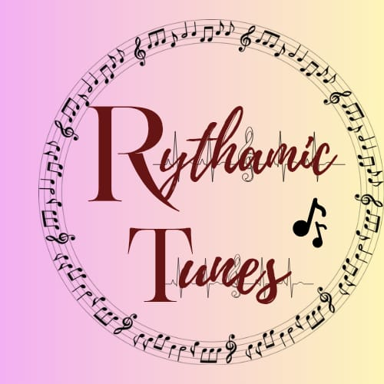  
: 🎵 **Rhythmic tunes** refer to musical compositions where rhythm plays a central role in shaping the sound and feel of the music. Rhythm is the pattern of beats, silences, and accents that organize sound over time, giving music its pulse and movement. In rhythmic tunes, these patterns are often repetitive, catchy, and structured to create a sense of groove or momentum. Whether it's the steady thump of a bass drum in a dance track or the syncopated beats of jazz, rhythmic tunes rely on timing and beat placement to energize listeners and drive the musical experience forward. They can be fast or slow, simple or complex, but they always make you feel the beat.

A **melodic companion** refers to a musical element or part that supports and enhances a primary melody, often by providing harmonic, rhythmic, or contrapuntal depth. In musical compositions, the melodic companion doesn’t overshadow the main theme but instead complements it—like a trusted partner in a duet. This companion might be another instrument, voice, or even a secondary melodic line that interacts with the lead, creating a richer and more textured soundscape. Whether it's a piano weaving gentle chords beneath a vocal line or a violin echoing a singer’s phrases with subtle variations, the melodic companion plays a vital role in shaping the emotional and structural balance of the piece. It’s the art of being present, supportive, and musically intertwined without stealing the spotlight.

**🎹 Digital Audio Workstations (DAWs)**

DAWs are the backbone of music production, offering full control over rhythm and melody:

* **Ableton Live** – Great for live performance and beat-making
* **FL Studio** – Popular for electronic and hip-hop producers
* **Logic Pro X** – Ideal for melodic composition and orchestration

**🎼 Companion Apps & Hardware**

These enhance your workflow and performance:

* **Newzik** – A collaborative sheet music app for organizing and sharing scores
* **Page-turning pedals** – Hands-free control for musicians reading digital sheet music
* **iPad Pro** – Widely used by musicians for composing, performing, and managing scores

**🎵 GitHub Projects & Open Source Tools**

* Rhythmic Tunes GitHub Project – A creative initiative titled “Your Melodic Companion,” built with React and Vite, aimed at supporting musical development through code

**🧠 Why This Structure Works**

* **Separation of concerns**: Keeps code, audio, and documentation distinct.
* **Scalable**: Easily accommodates new phases, features, or compositions.
* **Creative flow**: The *Inspiration* folder lets you store reference tracks or rhythmic ideas to spark creativity.
* **Version control**: Works well with Git for tracking changes in both code and musical assets.

If you're building a music app or composing a multi-track project, this structure gives you the flexibility to grow while staying organized. Want help customizing it for a specific DAW or framework? I can tailor it to your setup.

**Core Features of *Rhythmic Tunes: Your Melodic Companion***

**🎶 1. Melody Generation & Support**

* Offers tools to create or assist with melodic lines
* May include AI-generated suggestions for harmonies or counter-melodies
* Helps composers build memorable themes using rhythmic motifs

**🥁 2. Rhythmic Pattern Builder**

* Allows users to design and experiment with rhythmic cells
* Supports layering of beats and syncopation
* Encourages exploration of tempo, groove, and meter

**🧠 3. Phase-Based Development**

* Structured into multiple phases (Phase 1 to Phase 5), possibly representing stages of composition or feature rollout
* Each phase may introduce new musical or technical capabilities

**💻 4. React + Vite Framework**

* Built using modern web technologies like React and Vite for fast performance and modularity
* Likely includes a user-friendly interface for composing and editing

**📁 5. Organized Project Structure**

* Includes folders for src, public, and db, suggesting backend support and scalable architecture
* May support saving and retrieving compositions or user preferences

**🎨 6. Visual & Interactive Elements**

* Potential for visual rhythm editors or melodic visualizers
* Could include drag-and-drop interfaces for arranging musical elements

**🌟 Bonus: Musical Intelligence**

According to music composition principles, rhythmic tunes often feature:

* **Defining rhythmic cells** that give character to a melody
* **Repetition and variation** to build tension and release
* **Interaction between rhythm and melody** to evoke emotion and movement

**📱 2. Mobile & Cross-Platform Support**

* Develop responsive mobile apps for iOS and Android
* Enable seamless syncing across devices for composing on-the-go

**🧠 3. Smart Playlist & Mood Detection**

* Use real-time mood analysis to curate rhythmic tunes for different emotional states
* Implement smart playlists that evolve based on listening habits

**🎛️ 4. Interactive Visual Composer**

* Add drag-and-drop interfaces for building rhythm and melody blocks
* Include visual feedback for harmonic compatibility and rhythmic balance

**🌐 5. Cloud Collaboration & Sharing**

* Allow users to co-create and share compositions in real time
* Integrate with platforms like GitHub or Newzik for version control and score sharing

**🔊 6. Advanced Audio Processing**

* Support for multi-track mixing and mastering
* Include effects like reverb, delay, and EQ tailored to rhythmic and melodic layers

**🎓 7. Learning Mode & Tutorials**

* Offer guided lessons on rhythm theory, melody construction, and harmony
* Include interactive challenges to improve musical skills

.